**REAL TIME TEST MONITORING**

A project work submitted to the Jamal Mohamed College (Autonomous), Tiruchirappalli in partial fulfillment of the requirements for the award of the degree of

**MASTER OF COMPUTER APPLICATIONS**

Submitted

by

**R. SAFDHAR**

**(Reg.No.18MCA005)**

Under the Guidance of

**DR. O.A.MOHAMED JAFAR M.Phil., Ph.D.,**

**Associate Professor,**

**Dept. of Computer Science,**

**Jamal Mohamed College,**

**Tiruchirappalli-620 020.**



**PG & RESEARCH DEPARTMENT OF COMPUTER SCIENCE**

**JAMAL MOHAMED COLLEGE (AUTONOMOUS)**

**College with Potential for Excellence**

**Accredited (3rd Cycle) with ‘A’ Grade by NAAC**

**(Affiliated to Bharathidasan University)**

**TIRUCHIRAPPALLI – 620 020**

**APRIL 2021**

**JAMAL MOHAMED COLLEGE (AUTONOMOUS)**

**College with Potential for Excellence**

**Accredited (3rd Cycle) with ‘A’ Grade by NAAC**

**(Affiliated to Bharathidasan University)**

**TIRUCHIRAPPALLI – 620 020**



This is to certify that this project work entitled

**REAL TIME TEST MONITORING**

is a bonafide record of the project work done

by

**R. SAFDHAR**

**(Register Number: 18MCA005)**

at Jamal Mohamed College (Autonomous), Tiruchirappalli during the year 2017-2020 in partial fulfillment of the requirements for the award of the degree of

**MASTER OF COMPUTER APPLICATIONS**

**DR. O.A.MOHAMED JAFAR Dr. G. RAVI**

**Associate Professor Head of the Department**

Submitted for the Viva Voce examination held at Jamal Mohamed College(Autonomous), Tiruchirappalli – 20 on _________________.

**Internal Examiner External Examiner**

**Dr. O.A. MOHAMED JAFAR M.Phil. ,Ph.D.,**

**Associate Professor,**

**Dept. of Computer Science,**

**Jamal Mohamed College (Autonomous),**

**Tiruchirappalli-620 020.**

**CERTIFICATE**

This is to certify that this project entitled “**REAL TIME TEST MONITORING**” submitted in partial fulfillment of the requirements for the award of the degree of Master of Computer Applications to the Jamal Mohamed College, Tiruchirappalli is a bonafide record of the work done by **R. SAFDHAR (Reg.No.18MCA005)** under my supervision and guidance**.**

**Date:**  **Signature of the Guide**

**ACKNOWLEDGEMENT**

First and foremost I am grateful to the Almighty God who has showered his blessings on me all through my life and throughout this project.

Words are inadequate to express our heartiest, sincere and grateful thanks to the following persons.

Our first teachers and well-wishers, our first guide, we first express our deepest gratitude to our parents who were our strength and for their constant support in our every single step.

I place on record my sincere gratitude from the bottom of my heart to our beloved Principal **Hajee Dr. S.ISMAIL MOHIDEEN, M.Sc., M.Phil., PGDCA., Ph.D. Principal,** Jamal Mohamed College(Autonomous) for giving me an opportunity to do this course in this prestigious institution.

I am deeply indebted to **Dr. G. Ravi, M.C.A., PGDBA., M.Phil., Ph.D. – Head, Department of Computer Science** and **Dr. D.I. George Amalarethinam, M.C.A., M.Phil., PGDBA., Ph.D. – Bursar & Director of MCA**, Jamal Mohamed College(Autonomous) for granting permission for this project work.

With the deep appreciation and sincere gratitude, I humbly and deeply thankful to my project guide **Dr. O.A. Mohamed Jafar**. It is an immense pleasure to show my gratitude to him for he has been the greatest support in my project work.

Finally, I would like to express my love and gratitude to my beloved parents to who I dedicate this project for their love, support and encouragement whenever I feel disdained.

**R. SAFDHAR**

## **ABSTRACT**

This project title is “**Real Time Test Monitoring”**is a Desktop Application developed to monitor the Real Time Test. The purpose of test monitoring is to give feedback and visibility about test activities. Information to be monitored and collected automatically and used to measure exit criteria. The computerized system will improve the existing system that currently processes it manually. The computerized system will improve the existing system to provide the right information at the right time and will show the Upcoming Test Details of Student and Ongoing Progress of Test. This will help to get the report of Students if they are completed. It monitors the behaviour of Students while they write tests. The System Administrator and the faculties can get details anytime without any delay.

The features of the system include the following aspects,

* Backing up the files either automatically or manually
* Restoring the data whenever it is needed
* Track the Test Status

These systems are real-time dashboards and visualized data are updated continuously every 5 seconds the action occurs. It will help the Management to monitor the status of ongoing Tests. No worry about Test Report, it is stored in the database automatically whenever they want, they can generate Report. While Monitoring Ongoing Test it also monitors the login status of student and progress of the test.

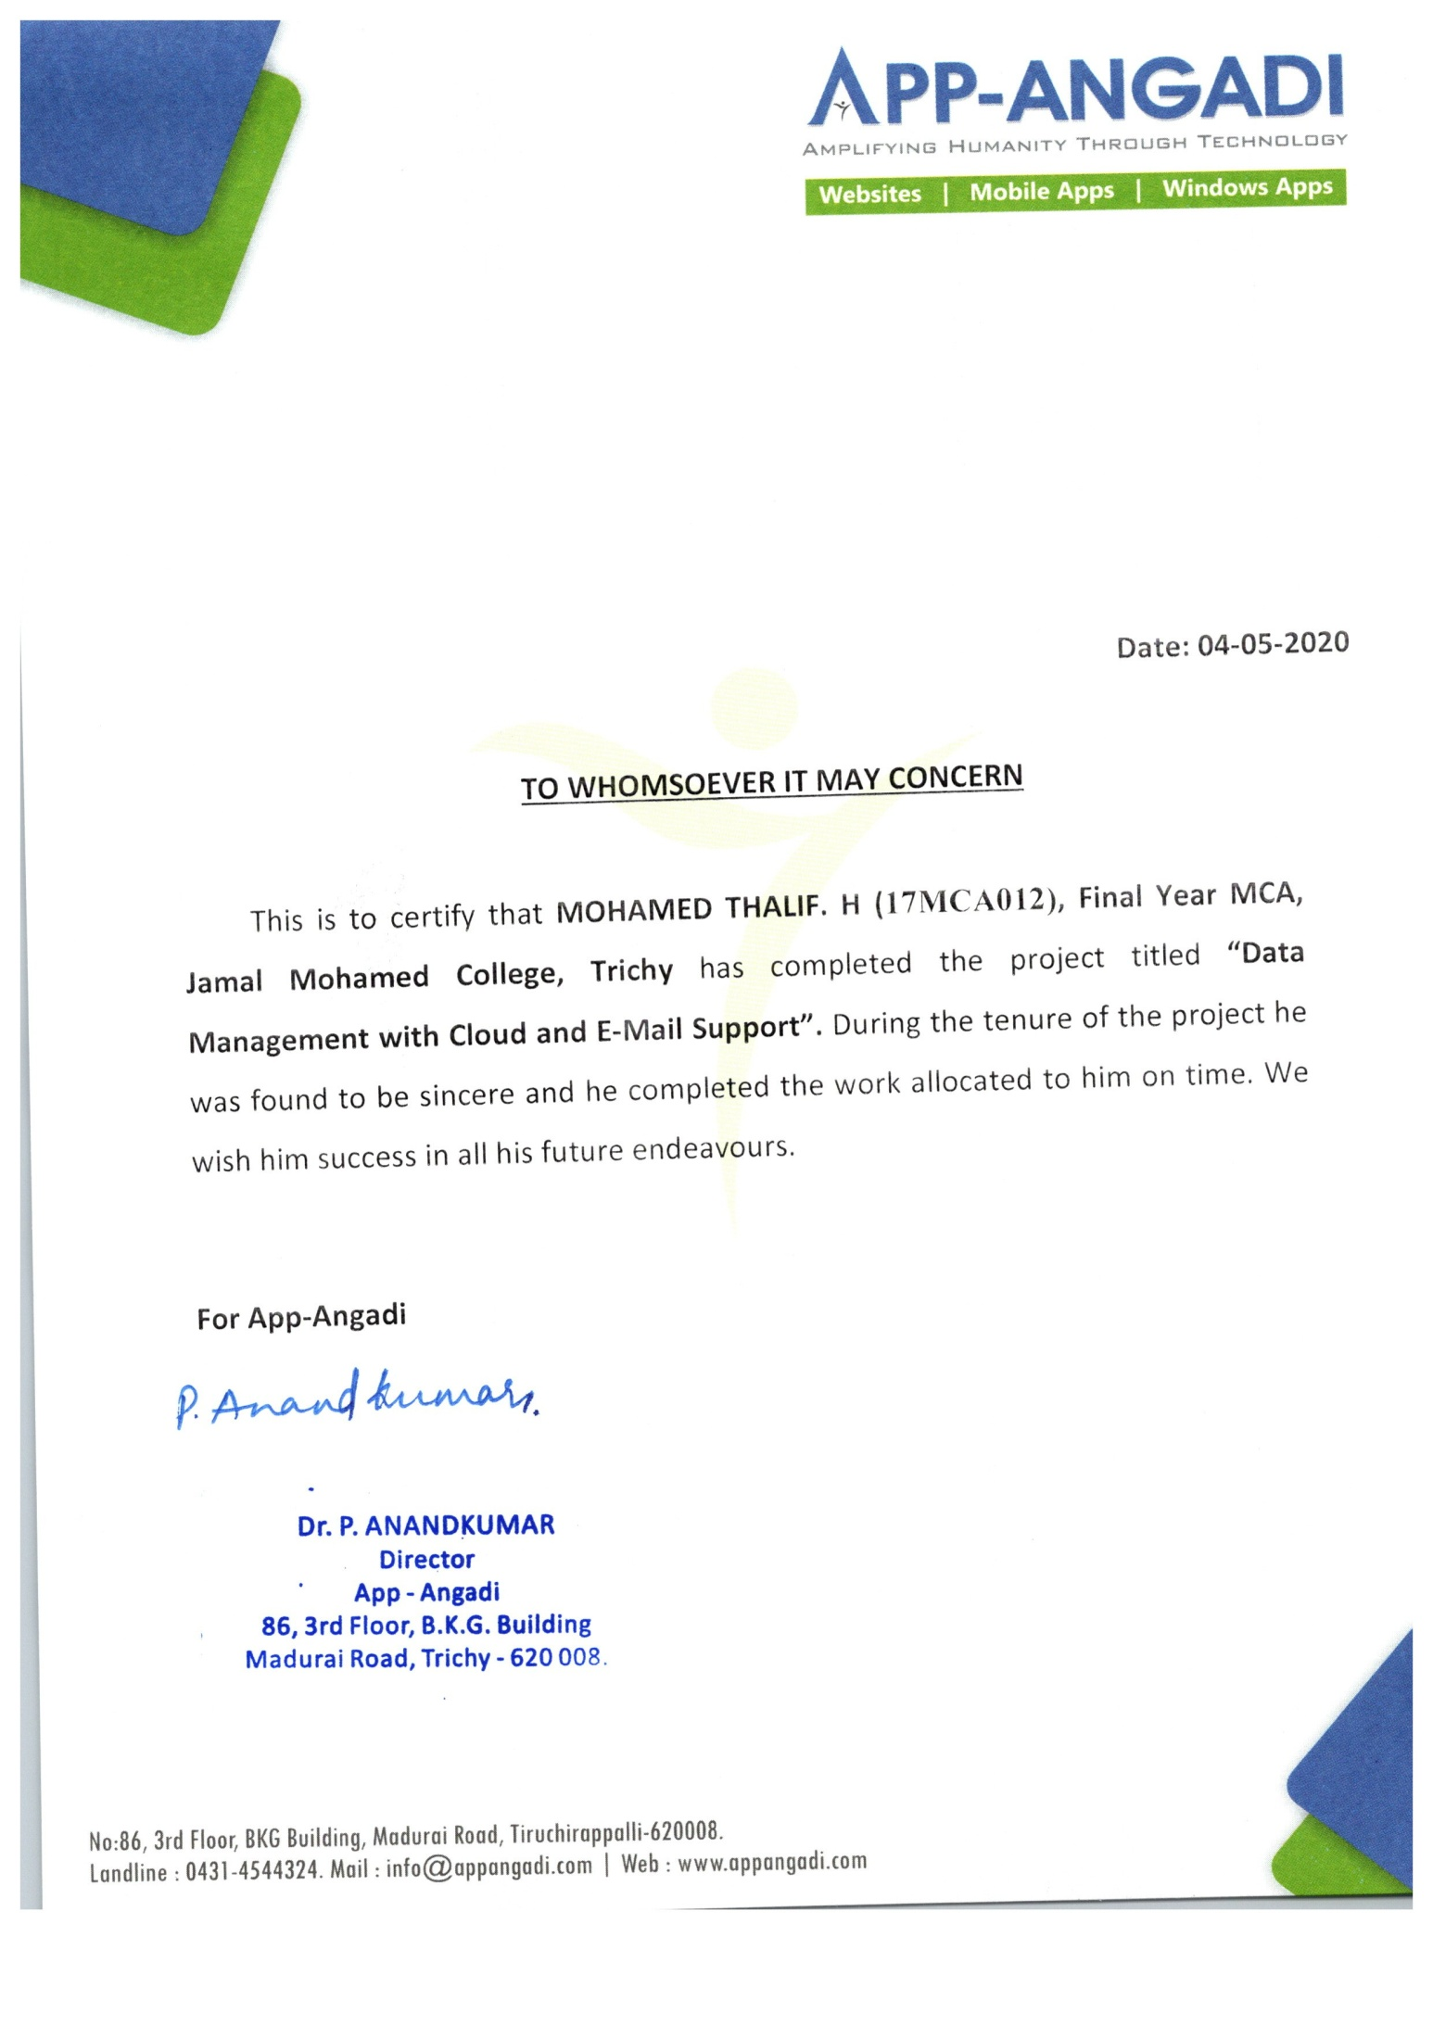

**CONTENTS**

|  |  |  |
| --- | --- | --- |
| **Ch. No.** | **Index** | **Page No.** |
|  | **CERTIFICATES** |  |
|  | **ACKNOWLEDGEMENTS** |  |
|  | **ABSTRACT** |  |
| 1 | **INTRODUCTION**   * 1. Problem Definition   2. Company Profile | 1  2 |
| 2 | **PROBLEM DESCRIPTION** |  |
|  | **SYSTEM STUDY** |  |
| 3 | * 1. Existing System   2. Proposed System | 5  5 |
|  | 3.3 Data Flow Diagram | 5 |
|  | 3.4 Data Dictionary | 6 |
|  | **SYSTEM CONFIGURATION** |  |
| 4 | 4.1 Hardware Requirements  4.2 Software Requirements | 10 |
| 5 | **OVERVIEW OF THE SOFTWARE** |  |
|  | **DESIGN AND DEVELOPMENT** |  |
| 6 | 6.1 Architectural Design | 21 |
|  | 6.2 Database Design | 22 |
| 7 | **USER MANUAL** |  |
| 8 | **CONCLUSION** |  |
|  | **BIBLIOGRAPHY** |  |
| **ANNEXURE** | **A SCREEN INTERFACES** |  |

**CHAPTER 1**

**INTRODUCTION**

“**Real Time Test Monitoring”** is a Test Monitoring Application. This monitoring software is employed to monitor the test takers and establish the exam’s credibility and authenticity. It is overseeing an exam and monitoring the students. In case a student has an issue while writing at the time of the exam, from our system the report says what issue they had when they write the exam. This System Shows the Upcoming Schedule with date and time, it show the Number of Batches write the ongoing test and Students overall present and it also show individual batch Students present and we can get report of completed tests.

These all data visualize in the form representation in the dashboard. It helps to see the these all data at one page. This dashboard is a real-time dashboard allowing to monitor activity as it happens throughout the whole process from upcoming to completed. Visualized data are updated continuously in less than a second after the action occurs. It will help to get enhanced report based on the visualized data. This help to find the how many batches are completed, how many students are present , how many batches are having test in feature, how they are completed their test.

* Shows details of batches who have tests on upcoming days
* At the day of test it shows, is all batches are taken exam or not
* Is all batches students are present or not
* Are they online or offline. If they are not online, their details will be shown in offline page
* Shows the Number of students presented at the particular batch
* It can give report of batches who completed test

These all data details will help the administrator to find the students and batch how they are performing.

This dashboard project is developed for desktop application by using WPF, C#, MS SQL Server and RDLC.

**CHAPTER 1**

**1.1 Problem Definition:**

The Management can’t offer a particular staff to Monitor Test of Every Batch from various classes and various subjects so our System will help to monitor how their students are performing in Test. Whether they are taking tests are seriously or not, how many students are presented for ongoing test and how many students are absent for that day test. If more than one batch is writing a test and if we want to record manually to check how many students are present in each batch it is the time taken and long process. With help of our system, it shows the overall present detail in each batch.

This system helps to monitor every batch test performance, it will help to get the report of the completed Test. So no need to write manually in the handbook or no need for any data operator to record these data. If we do manually or as data entry to record completion time of overall student of batch or each student completion time, is difficult to track these all. Each student can complete it at a different time or same time but that particular staff could be ready for these all to handle at any time to note down that detail. To avoid these all our system will help to the job as easier.

**CHAPTER 1**

## **1.2 Company Profile:**

Company Name : **APP – ANGADI**

External Guide Name : **Dr. P. Anand Kumar MCA, PhD.,**

Address : II Floor, BKG Building, No. 86 Madurai road, Tiruchirappalli– 620 008.

Email : [root.anand@gmail.com](mailto:root.anand@gmail.com)

Website : [www.appangadi.com](http://www.appangadi.com)

#### **About Company**



App – Angadi is a startup established in December 2009 as a private company to develop User Centered Applications. It aims at delivering applications on all platforms such as iOS, Android and Windows at time with full support and unlimited revisions. At App - Angadi, we combine business and technical knowledge based on the requirements of the client and ensure maximum Customer Satisfaction.

Our main aim is to provide a high quality application that complies to the given specification and deliver it within the stipulated time frame. We also support development lifecycle by providing functional and technical requirements through coding and testing. We are ready to deploy our extensive resources to meet customer’s challenges. It also acts as a great learning platform for students who joins here as an intern to have a real time experience on a working environment.

**CHAPTER 2**

# **PROBLEM DESCRIPTION**

The “**Real Time Test Monitoring and Anomaly Detection for Computer Based Test”** is a Test Monitoring System for Students. If Any Batch has Exam it shows the Upcoming Schedule. If any batch writes a test it shows the details of batch how many students attend the test now, how many students completed and how many students are offline. It shows how many batches completed the test.

The modules of this project are categorized based on Management needs and the description modules are mentioned as follows:

**Real Time Test Monitoring Dashboard:**

Real Time Test Monitoring Dashboard will visualize the following,

* Upcoming
* Today
* Completed

**Upcoming:**

In Upcoming, it shows the upcoming tests of a batch. It shows the test date, time and Start Type which is manual or auto-launch. Here we can change the manual into auto or auto into the manual. If any test set into autostart it launch automatically at the time for that particular batch. They can take the test at that time and date. If any test set into manual, that particular test will be move exactly at that time on that date onto Today Module to launch. And these all stored in the Database after every change.

**Today:**

In Today, it shows the Ongoing Tests. If more than one batch writes the test, it shows all students details of the ongoing test. It shows How many Tests are going at that time, How Many Students have Attended the Test, How many Students have Attended the Test but currently offline, How many students are completed and the Remaining Duration of the Test.

**CHAPTER 2**

Each Student details have Student Id, Name of the Student, Class, Batch name, How many questions Attended, Test Completed or Not and How They are Submit their Test like They Complete Between Duration of Test or it’s a Timeout or Tab Closed.

**Completed:**

In Completed, it shows the details of the Completed Test. It helps to get a report of the particular batch test, we can get a subject report.

The report have Test Name, Number of Questions , Name of the student, Number of Correct Answer, Number Wrong Answer, Mark and Average.

We get a report with the help of RDLC. RDLC stands for Report Definition Language Client-Side using Microsoft Reporting Technology. It is not a third-party report and is a built-in Microsoft Visual Studio.

If the Correct Answer Option is accidentally changed by any mistake and want to change that Question Answer we can change it by click on Edit and Change Option of Correct Answer for that Question, After that change, it will update all students who write that as correct answer.

**CHAPTER 3**

# **SYSTEM STUDY**

## **3.1 Existing System**

In the present System there is no possibility monitor multiple batches who write the test at the same time and get the report of that student after completion. The traditional exam invigilation is where an invigilator conducts exam at physical testing centers. There is a fixed date, time and venue for the exam where in the invigilator and the applicants are face to face during the suprevison. And traditional invigilation requires a ratio of one invigilator for approximately 36 candidates.

We want to assign one person to Mark the attendance and authenticate students appearing for the exam. Monitor applicants during the examination. And Taken time to give report of the particular students mark. These all take time too long

**Disadvantages of Existing System**

* Difficult to monitor all student of all batches at one time
* It’s a time consuming process
* If may it happened in manual process so sometime the data may not be the correct one. May some important information be lost or overloaded by humans.
* Slow process to give report of test and sometimes may it takes too long for report

## **Proposed System**

The Proposed System is a web-based dashboard and It helps management to see the Test Monitoring on One Page. The dashboards are real-time dashboards that allow to monitor the students who write test on their schedule like their login time, their test duration, attendance to that student, giving report to batch after completing the test.

If student is not present it is easier to inform management to who is not still not came for exam, if student is offline we can inform that student to came online or resolve their issue. These all not taken too long to find. It shows automatically from the database.

**Advantages of Proposed System**

* Faster and Effective access the date
* Less Time-Consuming
* Real Time dashboard
* User-friendly
* Easily understandable data visualization
* No need to data entry it is automated from the database

## **Data Flow Diagram**

A Data Flow Diagram (DFD) is a graphical representation of the "flow" of data through an information system, modelling its process aspects. Often they are a preliminary step used to create an overview of the system which can later be elaborated. DFDs can also be used for the visualization of data processing (structured design).

A DFD shows what kinds of information will be input to and output from the system, where the data will come from and go to, and where the data will be stored. It does not show information about the timing of processes, or information about whether processes will operate in sequence or in parallel. Data flow diagrams can be used to provide the end user with a physical idea of where the data they input ultimately has an effect upon the structure of the whole system from order to dispatch to report. How any system is developed can be determined through a data flow diagram model.

**DFD Symbols**

1. **Rectangle**

Source or Destination for data, external entity

1. **Arrow**

Flow of Data

1. **Circle**

Process of data

1. **Open Rectangle**

Data Store



1. A Data Flow has only one direction of flow between symbols. It may flow in both directions between a process and a data store to show a read before an update. The latter is usually indicated, however by two separate arrows since these happen at different type.
2. A join in DFD means that exactly the same data comes from any of two or more different processes data store or sink to a common location.
3. A data flow cannot go directly back to the same process it leads. There must be at least one other process that handles the data flow produce some other data flow returns the original data in the beginning process.
4. A data flow to a data store means update (delete or change).
5. A data flow from a data store means retrieve or use.

A Data flow has a noun phrase label more than one data flow noun phrase can appear on a single arrow as long as all of the flows on the same arrow move together as one package. In this fig 3.3.1 shows how the Dashboard get the details and flow diagram.

Upcoming Dashboard get the data from student database, it get details of upcoming batch test date details, test name, test launch type.

Ongoing page get the data from student database, it get details of Ongoing test details student name, batch name, remaining duration, attendance of students, offline details, if test is manual launch then it get that details also.

Completed page get the data from student database, it get details of Completed test details of batches. Get the test name, date of test, number of questions, which class , answer keys to edit if any changes want to update in answer key. If any change made on answer key it will be update on student database.

Student Database

COMPLETED DASHBOARD

ONGOING DASHBOARD

UPCOMING DASHBOARD

**Fig 3.3.1:** Data Flow Diagram for Real Time Test Monitoring

## **Data Dictionary**

|  |  |
| --- | --- |
| **Field Name** | **Description** |
|  |  |
|  |  |
|  |  |
|  |  |
|  |  |
|  |  |
|  |  |